ONLINE PERMITTING
To pay for a previously submitted permit OR to search previous/current building permits for a specific property follow the instructions below:
- Click on the “Permits and Inspections” tab located on the right side of the main screen.
- Enter the location in the filed provided.
- Click on “details” to review the details of a specific permit.
- If you wish to pay for a permit by credit card or eye check, select the permit and click “add to cart”. You may pay for multiple permits at once.

To submit a permit application for an Electrical, Electrical Service, Plumbing, Gas, Low Voltage, Gas Fireplace, Standby & Portable Generator and all Fuel Appliances (new or replacements). Example: oil tanks, air conditioning units, furnaces, mini splits, see below:
- Click the “Click here to apply online” link.
- Select permit type. Please note: you may only apply for ONE permit at a time. For example, if you are installing a gas furnace and gas piping, you must complete & submit TWO separate permit applications. However, they may be paid for together.
- Search location where work will be taking place. Select correct location and continue.
- Fill out information requested and click “continue”.
- Confirm information is correct and press the “submit” button. You will receive a message your permit has been accepted.

Once confirmation of your permit submission is received, you MUST upload your applicable State of NH Electrical, Plumbing, Gas, Hearth or Mechanical license, to complete the process. If you upload a copy of your businesses corporate license you must also include a photo ID of who is doing the work. You may upload these documents in the field at the bottom, left of your confirmation screen. (See below). Uploaded documents should be in the .pdf format.
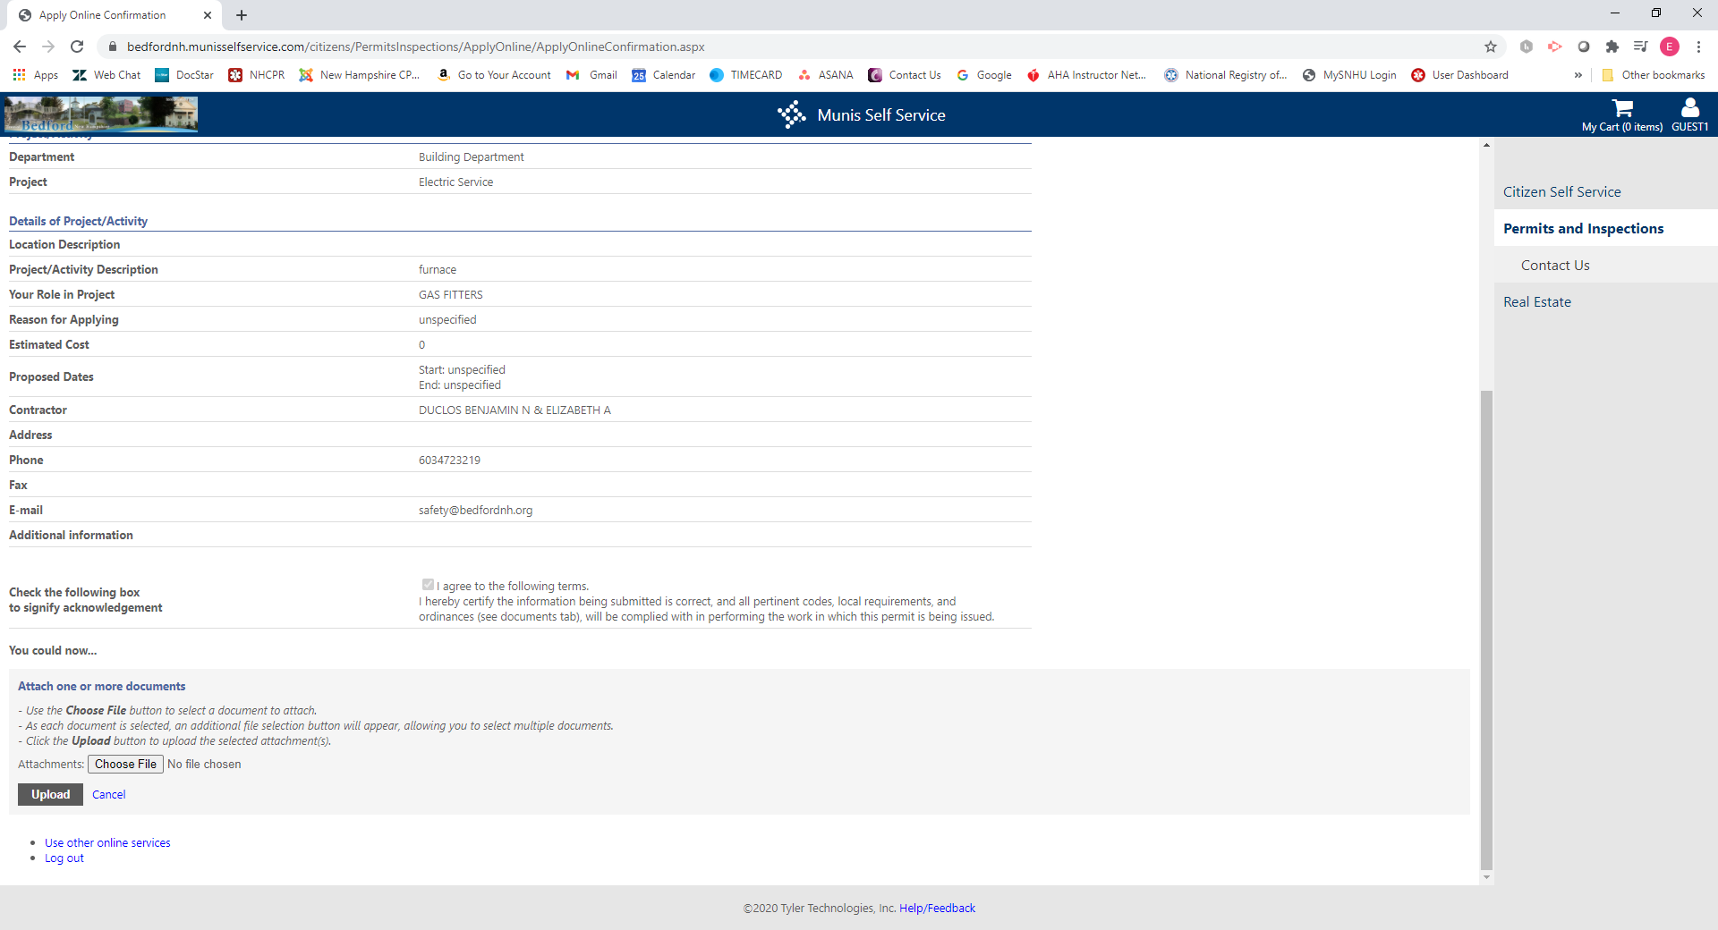

Permits, which do not have a valid license uploaded, will NOT be processed and no inspections will be completed until the information is received. If you are unable to upload a copy of your license or photo ID, you may email the information to safety@bedfordnh.org. Please include your application reference number in the email as well as the address where the permit is being issued.

GENERAL REMINDER TO ALL PERMIT APPLICANTS: Both the Town Zoning regulations, § 275-85 B, and the current building codes prohibit any work requiring a permit being started, including excavation for foundations, without a permit first being issued. Starting work without a permit is subject to a fine as outlined in §92-11.
Inspections may not be requested online. Please call the inspect line at 603-472-4567 to leave an inspection request.

